1. Screen image of the emulator showing the MainActivity with the calculated result.

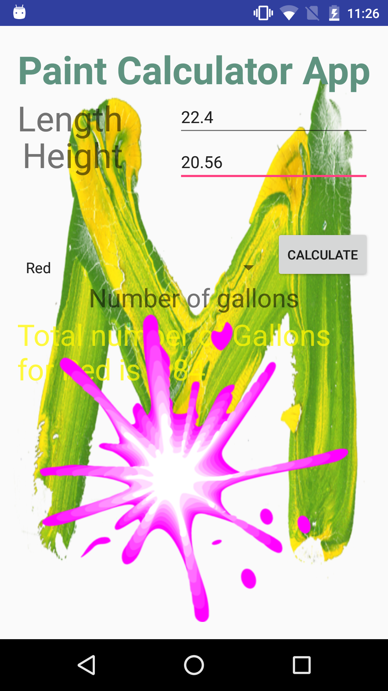

1. Copy and paste the contents of MainActivity.java

**package** com.sunny.menesh.paintshop;  
  
**import** android.support.v7.app.AppCompatActivity;  
**import** android.os.Bundle;  
**import** android.view.View;  
**import** android.widget.Button;  
**import** android.widget.EditText;  
**import** android.widget.Spinner;  
**import** android.widget.TextView;  
  
**import** java.text.DecimalFormat;  
  
**public class** MainActivity **extends** AppCompatActivity {  
  
 **double lengthOfWall**,**heigthOfWall**;  
 **double totalGallons**;  
 **double area**;  
 **double gallon** = 250;  
 String **color1**;  
 DecimalFormat **currency** = **new** DecimalFormat(**"##.00"**);  
  
 @Override  
 **protected void** onCreate(Bundle savedInstanceState) {  
 **super**.onCreate(savedInstanceState);  
 setContentView(R.layout.***activity_main***);  
  
 Button calculate = (Button)findViewById(R.id.***button***);  
  
 calculate.setOnClickListener(**new** View.OnClickListener() {  
 @Override  
 **public void** onClick(View v) {  
  
 EditText length = (EditText)findViewById(R.id.***wallLength***);  
 EditText height = (EditText)findViewById(R.id.***wallHeight***);  
 TextView total = (TextView)findViewById(R.id.***textTotal***);  
 Spinner color = (Spinner)findViewById(R.id.***spinner***);  
 **lengthOfWall** = Double.*parseDouble*(length.getText().toString());  
 **heigthOfWall** = Double.*parseDouble*(height.getText().toString());  
 **area** = **heigthOfWall** * **lengthOfWall**;  
  
 **totalGallons** = **area** / **gallon**;  
  
 **color1** = color.getSelectedItem().toString();  
  
 String outputLine;  
 outputLine = **"Total number of Gallons for "**+ **color1**+**" is "**;  
 outputLine += **currency**.format(**totalGallons**);  
 total.setText(outputLine);  
  
  
 }  
 });  
 }  
}

1. Copy and paste the contents of activity_main.xml

*<?***xml version="1.0" encoding="utf-8"***?>*<**RelativeLayout xmlns:android="http://schemas.android.com/apk/res/android"  
 xmlns:tools="http://schemas.android.com/tools"  
 android:layout_width="match_parent"  
 android:layout_height="match_parent"  
 android:paddingBottom="@dimen/activity_vertical_margin"  
 android:paddingLeft="@dimen/activity_horizontal_margin"  
 android:paddingRight="@dimen/activity_horizontal_margin"  
 android:paddingTop="@dimen/activity_vertical_margin"  
 tools:context="com.sunny.menesh.paintshop.MainActivity"  
 android:background="@drawable/paint3"**>  
  
 <**TextView  
 android:layout_width="wrap_content"  
 android:layout_height="wrap_content"  
 android:text="@string/textTitle"  
 android:id="@+id/textTitle"  
 android:layout_alignParentTop="true"  
 android:layout_centerHorizontal="true"  
 android:textSize="42sp"  
 android:textStyle="bold"  
 android:textColor="#5f9380"  
 android:enabled="false"** />  
  
 <**EditText  
 android:layout_width="wrap_content"  
 android:layout_height="wrap_content"  
 android:inputType="numberDecimal"  
 android:ems="10"  
 android:id="@+id/wallLength"  
 android:hint="in sq.feet"  
 android:layout_alignTop="@+id/textView"  
 android:layout_alignEnd="@+id/button"** />  
  
 <**EditText  
 android:layout_width="wrap_content"  
 android:layout_height="wrap_content"  
 android:inputType="numberDecimal"  
 android:ems="10"  
 android:id="@+id/wallHeight"  
 android:hint="in sq.feet"  
 android:layout_below="@+id/wallLength"  
 android:layout_alignParentEnd="true"** />  
  
 <**TextView  
 android:layout_width="wrap_content"  
 android:layout_height="wrap_content"  
 android:id="@+id/textView"  
 android:text="Length"  
 android:textSize="32dp"  
 android:layout_below="@+id/textTitle"  
 android:layout_alignParentStart="true"** />  
  
 <**TextView  
 android:layout_width="wrap_content"  
 android:layout_height="wrap_content"  
 android:id="@+id/textView2"  
 android:text="Height"  
 android:textSize="32dp"  
 android:layout_alignBaseline="@+id/wallHeight"  
 android:layout_alignBottom="@+id/wallHeight"  
 android:layout_alignEnd="@+id/textView"** />  
  
 <**Button  
 android:layout_width="wrap_content"  
 android:layout_height="wrap_content"  
 android:text="Calculate"  
 android:id="@+id/button"  
 android:layout_marginTop="47dp"  
 android:layout_below="@+id/textView2"  
 android:layout_alignParentEnd="true"** />  
  
 <**TextView  
 android:layout_width="wrap_content"  
 android:layout_height="wrap_content"  
 android:text="Number of gallons"  
 android:id="@+id/textView3"  
 android:textSize="28sp"  
 android:layout_below="@+id/button"  
 android:layout_centerHorizontal="true"** />  
  
 <**TextView  
 android:layout_width="wrap_content"  
 android:layout_height="wrap_content"  
 android:textAppearance="?android:attr/textAppearanceLarge"  
 android:id="@+id/textTotal"  
 android:layout_below="@+id/textView3"  
 android:layout_alignEnd="@+id/textTitle"  
 android:textSize="32sp"  
 android:textColor="#c2fff702"** />  
  
 <**Spinner  
 android:layout_width="wrap_content"  
 android:layout_height="wrap_content"  
 android:id="@+id/spinner"  
 android:layout_above="@+id/textView3"  
 android:layout_alignParentStart="true"  
 android:layout_toStartOf="@+id/button"  
 android:entries="@array/spnPaint"  
 android:prompt="@string/spnPaint"** />  
  
 <**ImageView  
 android:layout_width="wrap_content"  
 android:layout_height="wrap_content"  
 android:id="@+id/imageView"  
 android:src="@drawable/paint1"  
 android:layout_alignParentBottom="true"  
 android:layout_alignParentEnd="true"  
 android:layout_below="@+id/textView3"** />  
  
</**RelativeLayout**>

1. Copy and paste the contents of strings.xml

<**resources**>  
 <**string name="app_name"**>Paint shop</**string**>  
 <**string name="textTitle"**>Paint Calculator App</**string**>  
 <**string name="wallLength"**>Length of wall</**string**>  
 <**string name="wallHeight"**>Height of wall</**string**>  
 <**string name="spnPaint"**>Select a color</**string**>  
 <**string name="calculate"**>Calculate</**string**>  
 <**string-array name="spnPaint"**>  
 <**item**>Red</**item**>  
 <**item**>Yellow</**item**>  
 <**item**>Green</**item**>  
 <**item**>Blue</**item**>  
 <**item**>Navy Blue</**item**>  
 </**string-array**>  
</**resources**>